Assignment 1: (divanshi garg)

Q1)

#include<iostream>

using namespace std;

int main(){

int arr[100];

int n=0;

int choice;

do{

cout<<"\n Menu \n";

cout<<"1. Create\n";

cout<<"2. Display\n";

cout<<"3.Insert\n";

cout<<"4.Delete\n";

cout<<"5.Linear Search\n";

cout<<"6. Exit\n";

cout<<"enter your choice: ";

cin>>choice;

if(choice==1){

cout<<"enter the number of elements: ";

cin>>n;

cout<<"the elements";

for(int i=0;i<n;i++){

cin>>arr[i];

}

}

else if(choice==2){

if(n==0) cout<<"enpty\n";

else{

cout<<"array elements: ";

for(int i=0;i<n;i++){

cout<<arr[i]<<" ";

}

}

}

else if(choice==3){

int pos, val;

cout<<"enter the value: ";

cin>>val;

cout<<"enter the position: ";

cin>>pos;

if(pos<0||pos>n)

cout<<"invalid";

else{

for(int i=n;i>pos;i--){

arr[i]=arr[i-1];

}

arr[pos]=val;

n++;

}

}

else if(choice==4){

int pos;

cout<<"enter the position: ";

cin>>pos;

if(pos<0||pos>n)

cout<<"error";

else{

for(int i=pos; i<n-1;i--){

arr[i]=arr[i+1];

}

n--;

}

}

else if(choice==5){

int key, found =0;

cout<<"enter element to search ";

cin>>key;

for(int i=0;i<n;i++){

if(arr[i]== key){

cout<<"element found here!!"<<i<<endl;

found=1;

break;

}

}

if(found==0)

cout<<"not found";

}

else if(choice==6){

cout<<"exit\n";

}

else{

cout<<"invalid choice\n";

}

} while(choice !=6);

return 0;

}

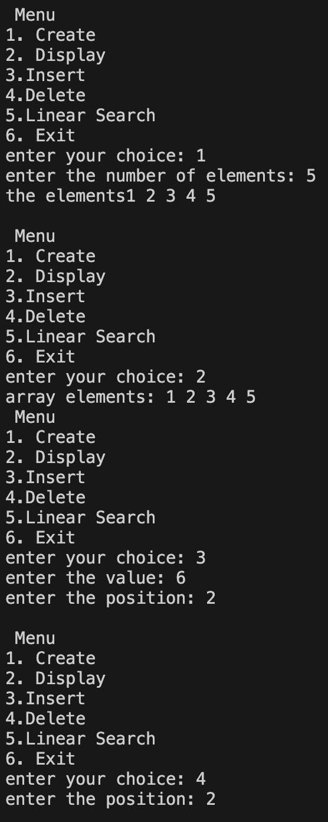         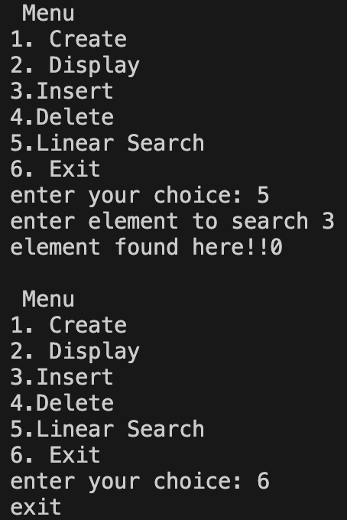

Q2

#include<iostream>

using namespace std;

int main() {

    int arr[10], n;

    cout << "Enter the number of elements: ";

    cin >> n;

    cout << "Enter the elements: ";

    for (int i = 0; i < n; i++) {

        cin >> arr[i];

    }

    for (int i = 0; i < n; i++) {

        for (int j = i + 1; j < n; ) {

            if (arr[i] == arr[j]) {

                for (int k = j; k < n - 1; k++) {

                    arr[k] = arr[k + 1];

                }

                n--;

            } else {

                j++;

            }

        }

    }

    cout << "Array after removing duplicates: ";

    for (int i = 0; i < n; i++) {

        cout << arr[i] << " ";

    }

    return 0;

}

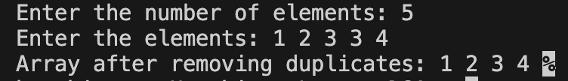

Q3)

#include<iostream>

using namespace std;

int main(){

    int i;

    int arr[5]={1};

    for(i=0;i<5;i++){

        cout<<arr[i];

    }

    return 0;

}



Q4 a)

#include<iostream>

using namespace std;

int main(){

    int arr[10],n;

    cout<<"enter the size of the array: ";

    cin>>n;

    cout<<"enter the elements: \n";

    for(int i=0;i<n;i++){

        cin>>arr[i];

    }

    cout<<"the reversed array is: ";

    for(int i=n-1;i>=0;i--){

        cout<<arr[i]<<" 5";

    }

    return 0;

}

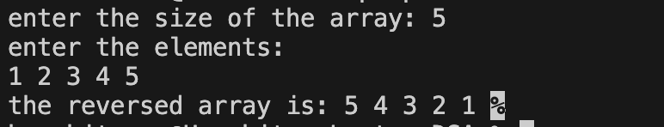

Q4b)

#include<iostream>

using namespace std;

int main() {

    int arr[10][10], brr[10][10], res[10][10];

    int r1, c1, r2, c2;

    cout << "Enter number of rows for 1st matrix: ";

    cin >> r1;

    cout << "Enter number of columns for 1st matrix: ";

    cin >> c1;

    cout << "Enter number of rows for 2nd matrix: ";

    cin >> r2;

    cout << "Enter number of columns for 2nd matrix: ";

    cin >> c2;

    if (c1 != r2) {

        cout << "Matrix multiplication not possible!" << endl;

        return 0;  // exit the program

    }

    cout << "Enter elements of 1st matrix:\n";

    for (int i = 0; i < r1; i++) {

        for (int j = 0; j < c1; j++) {

            cin >> arr[i][j];

        }

    }

    cout << "Enter elements of 2nd matrix:\n";

    for (int i = 0; i < r2; i++) {

        for (int j = 0; j < c2; j++) {

            cin >> brr[i][j];

        }

    }

    for (int i = 0; i < r1; i++) {

        for (int j = 0; j < c2; j++) {

            res[i][j] = 0;

            for (int k = 0; k < c1; k++) { // or k < r2

                res[i][j] += arr[i][k] \* brr[k][j];

            }

        }

    }

    cout << "\nResultant Matrix:\n";

    for (int i = 0; i < r1; i++) {

        for (int j = 0; j < c2; j++) {

            cout << res[i][j] << " ";

        }

        cout << endl;  // move to next row

    }

    return 0;   }

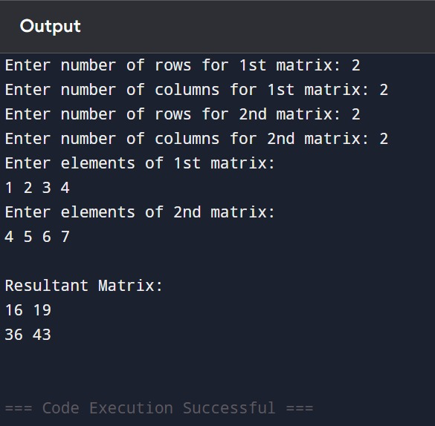

Q4c

#include<iostream>

using namespace std;

int main(){

    int arr[10][10], transpose[10][10];

    int rows, cols;

    cout<<"enter the rows and columns: ";

    cin>>rows>>cols;

    cout<<"enter the elements of matrix: ";

    for(int i=0;i<rows;i++){

        for(int j=0;j<cols;j++){

            cin>>arr[i][j];

        }

    }

    for(int i=0;i<rows;i++){

        for(int j=0;j<cols;j++){

            transpose[j][i]= arr[i][j];

        }

    }

    cout<<"the transpose is: ";

    for(int i=0;i<rows;i++){

        for(int j=0;j<cols;j++){

            cout<<transpose[i][j]<<" ";

        }

    }

return 0;  }

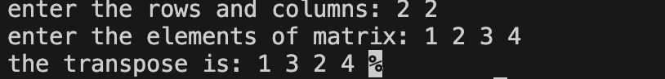

Q5)

#include<iostream>

using namespace std;

int main() {

    int rows, cols;

    cout << "Enter number of rows and columns: ";

    cin >> rows >> cols;

    int arr[100][100];

    cout << "Enter elements of the matrix:\n";

    for (int i = 0; i < rows; i++) {

        for (int j = 0; j < cols; j++) {

            cin >> arr[i][j];

        }

    }

    cout << "\nSum of each row:\n";

    for (int i = 0; i < rows; i++) {

        int rowSum = 0;

        for (int j = 0; j < cols; j++) {

            rowSum += arr[i][j];

        }

        cout << "Sum of Row " << i + 1 << " = " << rowSum << endl;

    }

    cout << "\nSum of each column:\n";

    for (int j = 0; j < cols; j++) {

        int colSum = 0;

        for (int i = 0; i < rows; i++) {

            colSum += arr[i][j];

        }

        cout << "Sum of Column " << j + 1 << " = " << colSum << endl;

    }

    return 0;

}